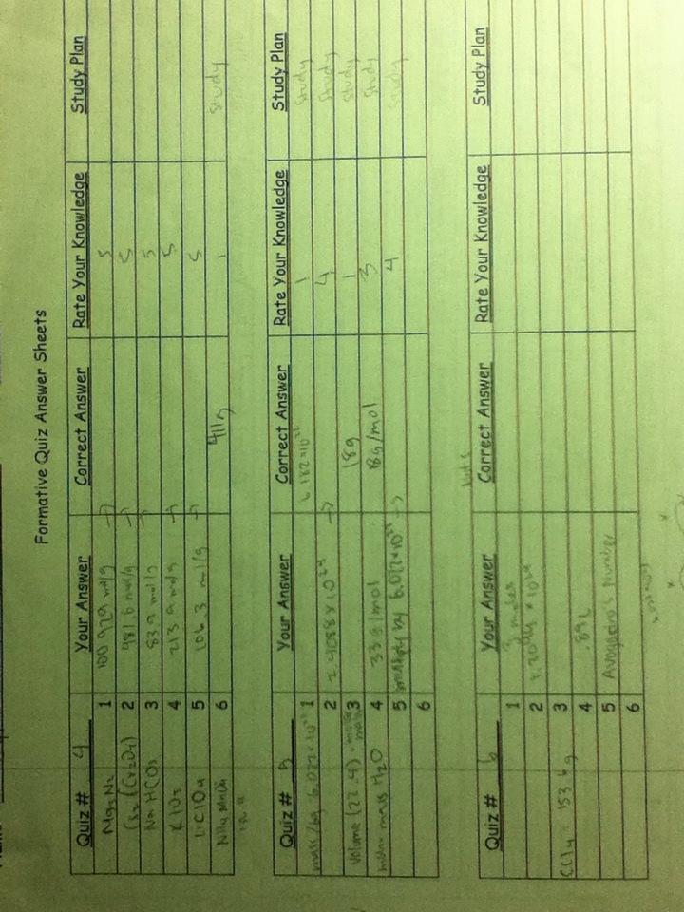

Quiz number 6, you did not fill out the correct answers, rate your knowledge, or write a study plan. Make sure to write it if you do not understand it so you know what to study for next time

Quiz number 5 it seems that you are lacking in stoichiometry, try doing more problems such as mass to mass or moles to mass, etc

Quiz number 4 there should be more study plans such as doing more practice